A PROJECT REPORT

ON

“Student ***Performance Analysis***”

SUBMITTED TO

OSMANIA UNIVERSITY

Submitted in partial fulfillment of the requirements for the

Award of degree Bachelor of Science

By

Noonsavath Nithin



OSMANIA UNIVERSITY

Department of Data Science

TARA GOVERNMENT DEGREE COLLEGE (AUTONOMOUS)

SANGAREDDY DISTRCT

## A PROJECT REPORT

ON

“A TOPIC STUDY ON STUDENT PERFORMANCE ANALYSIS”

SUBMITTED

 TO

**TARA GOVERNMENT DEGREE COLLEGE**

Department of Data Science

## Project Guide

## Dr. S. Naga Prasad,

## HOD OF DATASCINCE

Tara Government College(A), Sangareddy

## DECLARATION

**We Hereby declared the project work entitled: STUDENT PERFORMANCE ANALYSIS is being submitted to the department of DATASCIENCE, TARA GOVERNMENT COLLEGE(A+), Sangareddy in partial fulfillment of the requirement of the award of the BACHELOR OF SCIECE is a record of Bonafide project work carried out by we under the guidance of Dr. S. Naga Prasad. We further declare the work reported in this project has not submitted either in path of full for the award of any other degree or any other institute or university**

Place: **Sangareddy**

|  |  |  |  |  |  |
| --- | --- | --- | --- | --- | --- |
| S.NO. | Hall Ticket | Name | Subject | Year | Signature |
| 1. | 6058-21-539-008 | K. Bhavana | Datascience | III |  |
| 2. | 6058-21-539-009 | M. Ashwini | Datascience | III |  |
| 3. | 6058-21-539-014 | N.pundarikam | Datascience | III |  |
| 4. | 6058-21-539-015 | N. BHASKER | Datascience | III |  |
| 5. | 6058-21-539-016 | N. NITHIN | Datascience | III |  |
| 6. | 6058-21-539-017 | P. Manasa | Datascience | III |  |

CERTIFICATE

**This is to certify that the project work entitled**

“STUDENT PERFORMANCE ANALYSIS” **is presented by B.Sc (Data Science) students in partial fulfillment of the requirements for the degree of Bachelor Of Science by the Tara Govt College(A+),Sangareddy (Affiliated to Osmania University, Hyderabad) during the academic year 2023-2024.**

The results embodied in this report have not been to any other University or Institution for the award of any degree

## 

**PRINCIPAL Dr. S. Naga Prasad**

**TARA GOVT.COLLEGE(A+) Department of Datascience**

**SANGAREDDY-502001**



**ACKNOWLEDGEMENT**

I am thankful to my guide **Dr. S. Naga prasad Sir** HOD of Datascience consultant Tara government Degree & pg College Sangareddy, who has been a source Of encouragement, and who has helped me to complete the project

I profusely thankful to Head of the department of Datascience Dr. S. Naga prasad Sir, And Dr K.S.S. RATHNA PRASAD sir (principal of Tara government college, Sangareddy) for their suggestion and support.

Finally I thanks to my “group members” for helping to completing this project work.

**Dr. S. Naga prasad Sir**

(PRINCIPAL) (HOD of Datascience)

**TITLES OF CONTENTS**

|  |  |  |
| --- | --- | --- |
| S.NO. | CHAPTER | PAGES |
| 01. | Introduction | 07 - 07 |
| 02. | Team Structure and Roles | 08 - 9 |
| 03. | Project Overview | 10 - 11 |
| 04. | Tools and technologies | 12 - 13 |
| 05. | Data collection and Preparation | 14 - 16 |
| 06. | Exploratory Data Analysis | 17 - 21 |
| 07. | Influencing Factors | 22 - 25 |
| 08. | Solution and Recommendation | 26 - 29 |
| 09. | Implementation Plan | 29 - 32 |
| 10. | Challenges and Lessons Learned | 32 - 34 |
| 11. | Future Directions | 34 - 36 |

**INTRODUCTION**

The pursuit of academic excellence has long been a cornerstone of educational institutions worldwide. However, amidst the diverse landscape of student demographics, backgrounds, and learning styles, achieving consistent success remains a complex challenge. Considering this, our project endeavors to delve into the realm of student performance analysis, seeking to unravel the intricate web of factors that influence academic success.

The significance of this undertaking cannot be overstated. At its core, the project aims to shed light on the underlying dynamics that shape the educational journey of students, offering valuable insights for educators, administrators, policymakers, and stakeholders alike. By understanding the multifaceted nature of student performance, we can develop targeted interventions and strategies to support students in their quest for success.

Our objectives are twofold: first, to explore the intricate interplay between various academic metrics and student outcomes, and second, to identify actionable solutions to enhance student performance. Through rigorous analysis of student data spanning multiple semesters, we seek to uncover patterns, trends, and correlations that offer deeper insights into the factors influencing academic success.

By undertaking this project, we aspire to contribute meaningfully to the field of education by offering evidence-based insights and recommendations that have the potential to positively impact student outcomes. Our ultimate goal is to empower educators and institutions with the knowledge and tools they need to foster a supportive learning environment conducive to student growth and achievement.

**Team Structure and Roles**

Our project team comprises individuals with diverse backgrounds, expertise, and skill sets, each playing a crucial role in the successful execution of the project. Here, we outline the roles and responsibilities of each team member, highlighting their contributions to the project:

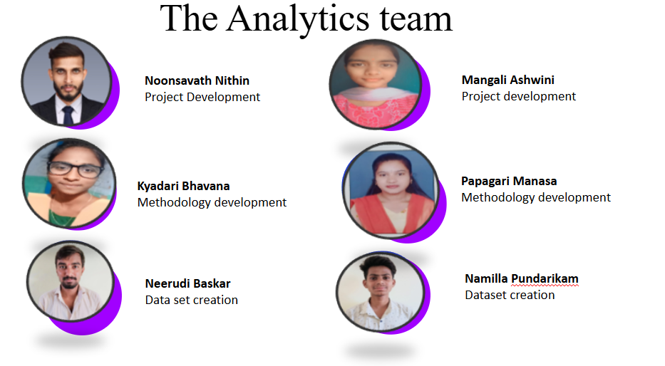

1. Nithin (Team Lead):
   * Nithin serves as the team lead, overseeing the project's development and ensuring its smooth execution from start to finish.
   * Responsibilities include project planning, coordination, and resource management.
   * Nithin provides strategic direction, guides team members, and facilitates communication among team members and stakeholders.
2. Ashwini (Team Development):
   * Ashwini is responsible for supporting the development efforts of the project, including data analysis, coding, and software development.
   * Tasks involve implementing algorithms, designing user interfaces, and troubleshooting technical issues.
   * Ashwini collaborates closely with other team members to ensure the timely delivery of project milestones.
3. Bhasker and Adithya (Dataset Creation):
   * Bhasker and Adithya are tasked with creating and curating the dataset used for the project's analysis.
   * Responsibilities include collecting data from various sources, cleaning and preprocessing the data, and organizing it into a structured format.
   * Bhasker and Adithya ensure the integrity and quality of the dataset, conducting thorough checks and validations to minimize errors.
4. Manasa and Bhavana (Methodology Development):
   * Manasa and Bhavana lead the methodology development efforts, designing the analytical framework and approach for the project.
   * Responsibilities include defining research questions, selecting appropriate statistical methods, and developing data analysis pipelines.
   * Manasa and Bhavana employ rigorous methodologies to ensure the validity and reliability of the project's findings.

Each team member brings unique skills, expertise, and perspectives to the project, contributing to its overall success. Through effective collaboration, communication, and teamwork, we strive to achieve our project goals and deliver impactful results.

**Project Overview:**

The project aims to conduct a comprehensive analysis of student performance to understand the factors influencing academic success and promote strategies for improvement. This overview provides insight into the project's scope, goals, and methodology employed for analysis.

Scope: The project focuses on analyzing student performance data collected from 50 students across six semesters. It encompasses various academic metrics such as attendance, assignment performance, seminar participation, and exam results.

Goals:

1. To identify key factors affecting student performance and promotion percentages.
2. To uncover correlations and relationships between academic metrics and student outcomes.
3. To provide actionable insights and recommendations for enhancing student performance and success.

Methodology: The project employs a mixed-methods approach combining quantitative analysis with qualitative insights. Data analysis involves descriptive statistics, exploratory data analysis (EDA), and inferential statistical techniques to uncover patterns, trends, and relationships within the dataset.

Additionally, qualitative methods such as interviews, surveys, and focus groups may be used to gather subjective perspectives and qualitative insights from stakeholders, including students, teachers, and administrators.

Overall, the project adopts a systematic and rigorous methodology to ensure robust analysis and meaningful interpretation of the findings. By leveraging both quantitative and qualitative approaches, we aim to provide a holistic understanding of student performance and inform evidence-based strategies for improvement.

Tools and Technology Utilized

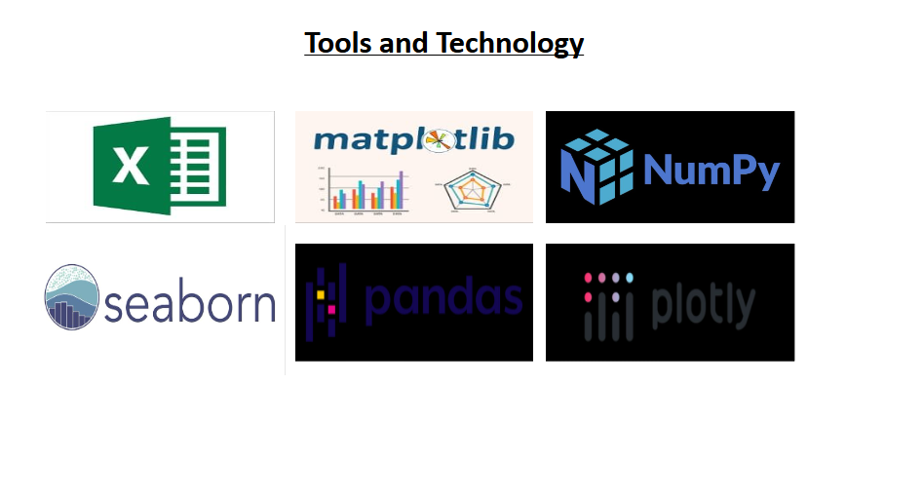

1. Python Programming Language:

- Python served as the primary programming language for data analysis and manipulation.

- It provided a versatile and robust framework for implementing various analytical algorithms and statistical techniques.

2. Excel for Data Creation:

- Microsoft Excel was used for creating and organizing the initial dataset.

- It facilitated data entry, management, and organization in a tabular format, allowing for easy manipulation and formatting.

3. Pandas and NumPy for Data Manipulation:

- Pandas and NumPy libraries were employed for efficient data manipulation and mathematical operations.

- Pandas provided powerful data structures like DataFrame for handling structured data, while NumPy offered support for numerical computing and array operations.

4. Matplotlib, Seaborn, and Plotly for Visualization:

- Matplotlib, Seaborn, and Plotly were utilized for data visualization and exploratory analysis.

- Matplotlib offered a wide range of plotting functionalities for creating static visualizations, while Seaborn provided high-level interface for statistical graphics. Plotly enabled interactive and dynamic visualizations for enhanced data exploration and presentation.

By leveraging these tools and technologies, you were able to conduct a comprehensive analysis of student performance data, manipulate datasets effectively, and visualize key insights for interpretation and communication.

Data Collection and Preparation

Data collection for the project involved a systematic process to gather relevant information on student performance from various sources. The following outlines the steps undertaken for data collection and preparation:

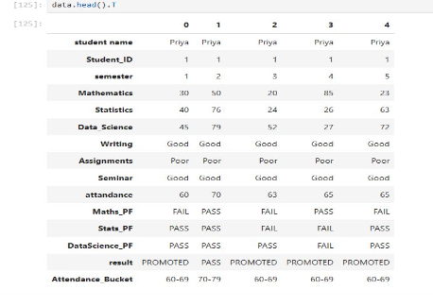

1. Source Identification: Initially, sources of student performance data were identified, including academic records, attendance registers, assignment submissions, and seminar participation logs. These sources provided comprehensive insights into different aspects of student performance.

2. Data Gathering: The data collection process involved retrieving information from the identified sources. Academic records were obtained from the educational institution's database, while attendance, assignment, and seminar data were collected manually from relevant records maintained by the institution.

3. Data Organization: Once collected, the data were organized systematically to facilitate analysis. Each data source was categorized and labeled accordingly to ensure clarity and ease of access during the analysis phase.

4. Data Cleaning: Data cleaning procedures were implemented to address any inconsistencies, errors, or missing values within the dataset. This involved tasks such as removing duplicates, correcting inaccuracies, and imputing missing data where possible.

5. Data Integration: After cleaning, the data from different sources were integrated into a single dataset for analysis. This integration process involved merging and consolidating data from multiple sources while ensuring data integrity and consistency.

6. Variable Selection: Relevant variables related to student performance, such as attendance percentages, assignment scores, seminar participation, and exam results, were selected for inclusion in the dataset. Careful consideration was given to choosing variables that would provide valuable insights into the factors influencing student success.

7. Data Formatting: The final step in data preparation involved formatting the dataset for analysis. This included standardizing variable formats, ensuring consistency in data types, and organizing the dataset into a structured format suitable for statistical analysis.

Challenges Encountered:

While the data collection process was generally smooth, several challenges were encountered along the way. These challenges included:

- Incomplete or inconsistent data entries in academic records.

- Difficulty in accessing certain data sources, particularly attendance and seminar participation logs.

- Time constraints and resource limitations for manual data collection and cleaning.

Despite these challenges, diligent efforts were made to overcome obstacles and ensure the integrity and quality of the dataset for analysis. Overall, the data collection and preparation process laid the foundation for conducting meaningful analysis and deriving valuable insights into student performance factors.

Exploratory Data Analysis (EDA)

During the exploratory data analysis phase, several key insights were gained from the dataset, shedding light on various aspects of student performance and factors influencing academic success. The following summarizes the key findings and observations derived from EDA: 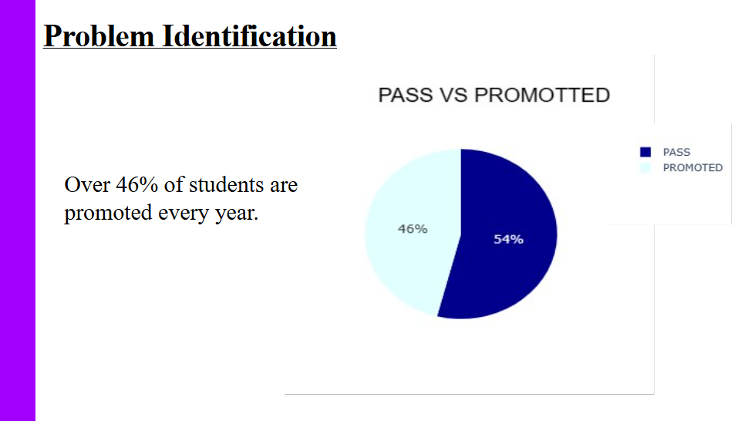

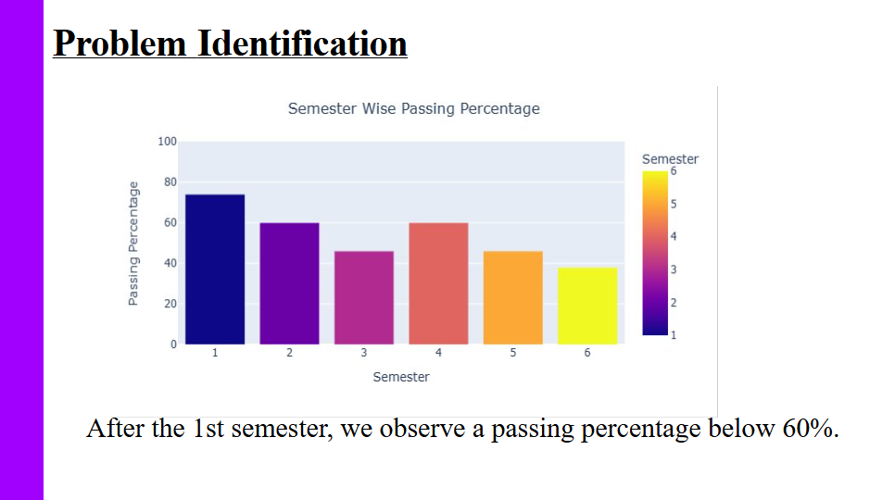

1. Attendance Analysis:

- Analysis of attendance data revealed a significant impact on student performance, with higher attendance percentages correlating positively with better academic outcomes.

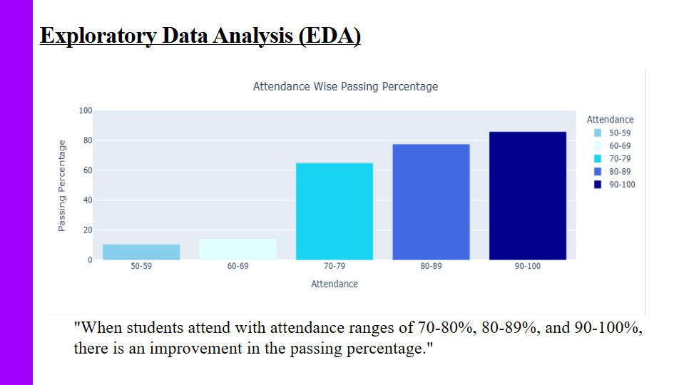

- Students with attendance percentages falling within the range of 70-80%, 80-89%, and 90-100% demonstrated higher passing percentages compared to those with lower attendance rates.

2. Assignment Performance:

- Evaluation of assignment performance highlighted its importance in predicting student success, with strong correlations observed between assignment scores and exam results.

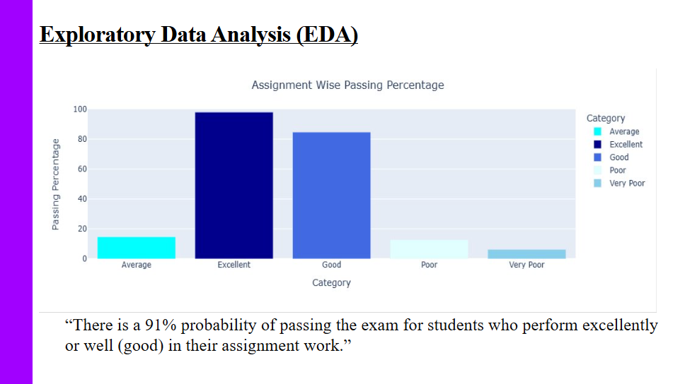

- Students who performed well in assignments, particularly those achieving excellent or good scores, exhibited higher probabilities of passing exams.

3. Seminar Participation:

- Seminar participation emerged as another influential factor affecting student performance, with notable correlations between seminar engagement and exam outcomes.

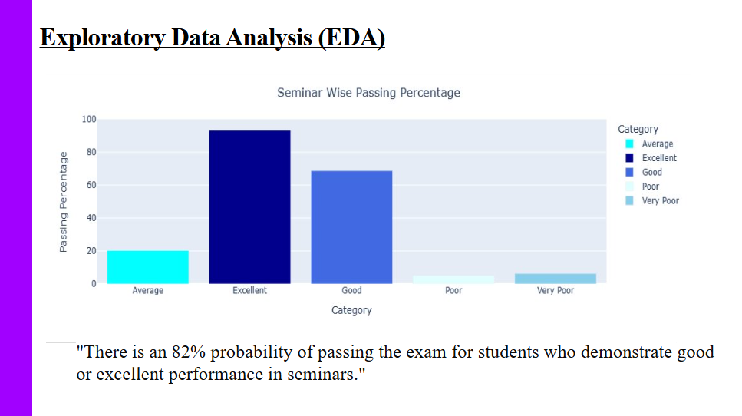

- Students demonstrating good or excellent participation in seminars were more likely to pass exams compared to those with poor participation.

4. Promotion Percentage Analysis:

- Analysis of promotion percentages revealed interesting trends, with a significant proportion of students being promoted each year despite varying levels of performance.

- Particularly noteworthy was the high promotion rate among students with poor, average, or very poor performance in assignments and seminars, indicating potential areas for intervention and support.

5. Correlation Analysis:

- Correlation analysis identified strong positive correlations between attendance, assignment performance, seminar participation, and exam results, underscoring the interrelated nature of these factors in determining student success.

Overall, the EDA phase provided valuable insights into the complex dynamics of student performance, highlighting the importance of factors such as attendance, assignment performance, and seminar engagement in shaping academic outcomes. These findings laid the groundwork for further analysis and the development of targeted interventions to enhance student success.

Factors Influencing Student Performance:

Through rigorous analysis of the dataset, several key factors influencing student performance were identified. These factors play a crucial role in determining academic outcomes and provide valuable insights into areas where targeted interventions may be beneficial. The following factors emerged as significant influencers of student performance:

1. Attendance:

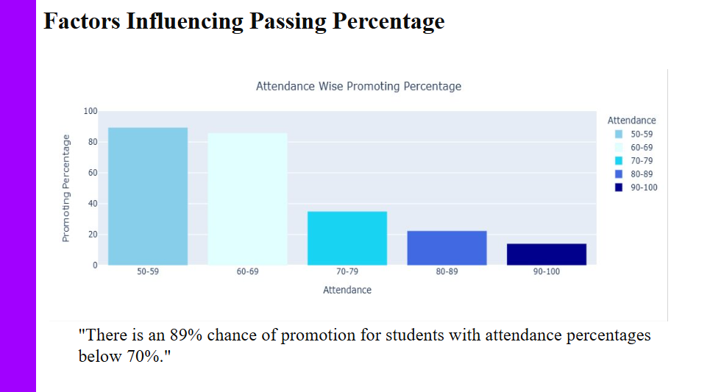

- Attendance emerged as a critical factor influencing student performance, with higher attendance percentages correlating positively with academic success.

- Students with regular attendance demonstrated higher passing percentages compared to those with irregular attendance or high rates of absenteeism.

- Analysis revealed that students with attendance percentages falling within the range of 70-80%, 80-89%, and 90-100% exhibited improved passing percentages, highlighting the importance of consistent attendance in achieving academic goals.

2. Assignment Performance:

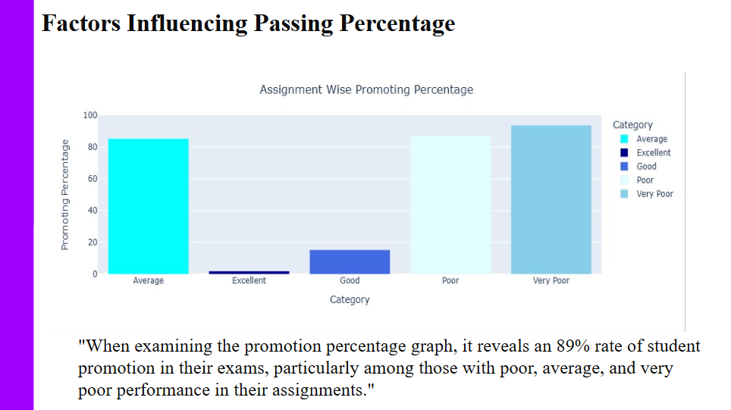

- Assignment performance was identified as another influential factor affecting student success, with strong correlations observed between assignment scores and exam results.

- Students who excelled in assignments, particularly those achieving excellent or good scores, showed higher probabilities of passing exams.

- Effective completion of assignments not only reflects students' understanding of course material but also enhances their preparation for exams, contributing to overall academic performance.

3. Seminar Participation:

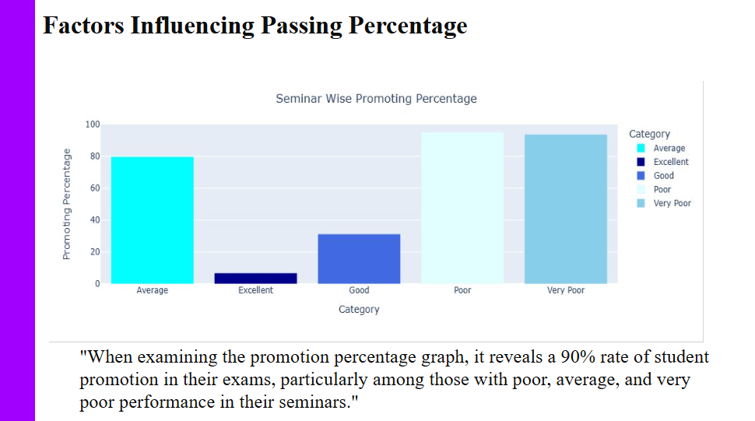

- Active participation in seminars emerged as a significant predictor of student performance, with notable correlations between seminar engagement and exam outcomes.

- Students who actively engaged in seminars, demonstrating good or excellent participation, exhibited higher passing percentages compared to those with poor participation.

- Seminar participation provides opportunities for collaborative learning, critical thinking, and discussion, all of which are essential for deepening understanding and retention of course content.

Overall, these factors collectively contribute to student success and underscore the importance of holistic support mechanisms to address barriers to learning. By understanding and addressing these influential factors, educational institutions can implement targeted interventions to foster a supportive learning environment and enhance student performance.

solutions and recommendations

1. Attendance Improvement Programs:

- Targeted Interventions: Design and implement targeted interventions tailored to address the specific needs of students with low attendance rates. These interventions may include personalized outreach, counseling sessions, or mentorship programs aimed at addressing underlying issues contributing to absenteeism.

- Incentives and Rewards: Offer incentives or rewards to incentivize and motivate students to improve their attendance. These incentives could range from recognition awards to tangible rewards such as gift cards or vouchers for achieving attendance milestones or maintaining consistent attendance throughout the semester.

- Support Services: Provide additional support services to students facing challenges in attending classes regularly. This may involve offering transportation assistance, childcare services, or flexible scheduling options to accommodate students' individual circumstances and commitments.

2. Seminar Performance Enhancement:

- Workshop Development: Develop and facilitate workshops or training sessions focused on enhancing seminar participation and engagement. These workshops could cover topics such as effective communication skills, active listening techniques, and strategies for constructive participation in group discussions.

- Peer Learning Opportunities: Encourage peer collaboration and peer-to-peer learning experiences within seminar settings. Implement group activities, collaborative projects, or peer review processes that promote interaction and knowledge sharing among students, fostering a supportive and inclusive learning environment.

- Feedback Mechanisms: Establish feedback mechanisms to solicit input from students regarding their seminar experiences and identify areas for improvement. Use student feedback to inform instructional practices and make adjustments to seminar formats, content, or delivery methods as needed to enhance student engagement and learning outcomes.

3. Assignment Feedback and Support:

- Timely Feedback: Prioritize timely and constructive feedback on assignments to help students identify strengths and areas for improvement. Implement grading rubrics or scoring guides to provide clear expectations and criteria for assessment, facilitating consistency and transparency in feedback delivery.

- Peer Collaboration: Promote peer collaboration and peer review processes as part of the assignment workflow. Encourage students to provide feedback to their peers and engage in collaborative learning activities that foster critical thinking, problem-solving, and peer support.

- Additional Resources: Offer supplemental resources and support services to assist students in mastering assignment content and concepts. This may include access to online tutorials, academic workshops, or writing centers staffed by qualified tutors who can provide individualized assistance and guidance.

4. Mentorship and Academic Support:

- Mentorship Programs: Establish mentorship programs pairing students with faculty mentors or peer mentors who can provide guidance, advice, and support throughout their academic journey. Mentors can offer academic and career-related guidance, serve as role models, and provide encouragement and motivation to help students succeed.

- Academic Counseling: Provide academic counseling services to help students navigate academic challenges, develop effective study habits, and set achievable academic goals. Academic counselors can offer personalized guidance, assist with course selection and academic planning, and provide referrals to support services as needed.

- Support Centers: Create dedicated academic support centers or resource hubs where students can access a wide range of support services, including tutoring, academic advising, study skills workshops, and disability support services. These centers can serve as centralized hubs for student support, providing a welcoming and inclusive space for students to seek assistance and resources.

5. Technology Integration:

- Digital Learning Tools: Explore the integration of digital learning tools and technology-enhanced instructional materials to enhance student engagement and learning outcomes. Incorporate interactive multimedia resources, online simulations, and virtual labs to supplement traditional classroom instruction and provide additional learning opportunities.

- Online Learning Platforms: Implement online learning platforms and course management systems to facilitate remote learning and asynchronous instruction. Provide students with access to course materials, lecture recordings, discussion forums, and collaborative online spaces where they can interact with peers and instructors outside of the traditional classroom setting.

- Technology Training: Offer technology training and support services to help students develop digital literacy skills and effectively utilize digital learning tools and platforms. Provide tutorials, workshops, and online resources to familiarize students with technology tools and empower them to leverage technology to support their learning and academic success.

By implementing these comprehensive solutions and recommendations, educational institutions can create a supportive and inclusive learning environment that empowers all students to thrive academically and achieve their full potential. Ongoing evaluation and assessment of the effectiveness of these interventions are essential to ensure continuous improvement and student success.

implementation plan for the proposed solutions:

1. Attendance Improvement Programs:

- Implementation Strategies:

- Develop targeted interventions tailored to address specific attendance challenges faced by students.

- Offer incentives and rewards to motivate students to improve attendance.

- Provide support services such as counseling, mentorship, or transportation assistance to address underlying issues contributing to absenteeism.

- Monitoring and Evaluation:

- Track attendance data regularly to monitor changes in attendance rates over time.

- Conduct surveys or focus groups to gather feedback from students regarding the effectiveness of attendance improvement programs.

- Analyze academic performance data to assess the impact of improved attendance on student outcomes, such as grades and graduation rates.

2. Seminar Performance Enhancement:

- Implementation Strategies:

- Develop workshops and training sessions focused on enhancing seminar participation and engagement.

- Encourage peer collaboration and peer-to-peer learning experiences within seminar settings.

- Establish feedback mechanisms to solicit input from students regarding their seminar experiences.

- Monitoring and Evaluation:

- Collect feedback from students after each seminar session to assess engagement levels and satisfaction with the content and format.

- Monitor seminar attendance and participation rates to gauge the effectiveness of intervention strategies.

- Evaluate student performance on seminar-related assignments or assessments to measure improvements in learning outcomes.

3. Assignment Feedback and Support:

- Implementation Strategies:

- Provide timely and constructive feedback on assignments to help students identify strengths and areas for improvement.

- Promote peer collaboration and peer review processes as part of the assignment workflow.

- Offer supplemental resources and support services to assist students in mastering assignment content.

- Monitoring and Evaluation:

- Review student feedback on assignment feedback processes to identify areas for improvement and refinement.

- Assess changes in assignment completion rates and quality of work over time.

- Analyze student performance on assignment-related assessments to measure improvements in learning outcomes.

4. Mentorship and Academic Support:

- Implementation Strategies:

- Establish mentorship programs pairing students with faculty mentors or peer mentors.

- Provide academic counseling services to help students navigate academic challenges and set achievable goals.

- Create dedicated academic support centers or resource hubs where students can access a wide range of support services.

- Monitoring and Evaluation:

- Monitor mentorship program participation and satisfaction levels among students and mentors.

- Conduct regular surveys or focus groups to gather feedback from students regarding academic counseling services.

- Track utilization rates and outcomes of academic support center services to assess effectiveness and identify areas for improvement.

5. Technology Integration:

- Implementation Strategies:

- Explore the integration of digital learning tools and technology-enhanced instructional materials into the curriculum.

- Implement online learning platforms and course management systems to facilitate remote learning and asynchronous instruction.

- Offer technology training and support services to help students develop digital literacy skills.

- Monitoring and Evaluation:

- Collect data on student engagement and satisfaction with digital learning tools and online platforms.

- Assess student performance on technology-enhanced assignments or assessments to measure the impact on learning outcomes.

- Monitor technology training participation and proficiency levels among students to evaluate the effectiveness of support services.

By implementing this comprehensive implementation plan, educational institutions can effectively address the identified challenges and improve student performance across various domains. Ongoing monitoring and evaluation efforts are essential to ensure the success and sustainability of these initiatives.

challenges and lessons learned during the project:

1. Data Collection Challenges:

- Discuss any difficulties encountered during the data collection process, such as obtaining access to relevant datasets, ensuring data quality, or managing large volumes of data.

- Reflect on strategies employed to address these challenges, such as collaborating with data providers, implementing data validation procedures, or utilizing data cleaning techniques.

2. Analytical Complexity:

- Describe any complexities or nuances encountered during the data analysis phase, such as dealing with missing data, handling outliers, or selecting appropriate analytical techniques.

- Share insights gained from navigating these complexities, including the use of statistical methods, machine learning algorithms, or visualization tools to uncover patterns and insights in the data.

3. Interdisciplinary Collaboration:

- Highlight the interdisciplinary nature of the project and the challenges associated with integrating expertise from multiple domains, such as data science, education, and psychology.

- Discuss the benefits of interdisciplinary collaboration in addressing complex research questions and generating novel insights from diverse perspectives.

4. Communication and Stakeholder Engagement:

- Reflect on the importance of effective communication and stakeholder engagement throughout the project lifecycle, including engaging with project team members, academic advisors, institutional leaders, and external collaborators.

- Discuss strategies for fostering open communication, managing expectations, and soliciting feedback from stakeholders to ensure project success.

5. Time and Resource Constraints:

- Acknowledge any constraints related to time, budget, or resources that impacted project planning and execution.

- Share strategies for prioritizing tasks, optimizing resource allocation, and adapting to changing project requirements in response to constraints.

6. Lessons Learned:

- Summarize key lessons learned from the project experience, including insights gained, best practices identified, and areas for improvement in future projects.

- Reflect on personal growth and professional development opportunities resulting from participation in the project, such as developing new skills, expanding domain knowledge, or building collaborative relationships.

By candidly discussing challenges faced and lessons learned throughout the project, you can provide valuable insights for future research endeavors and contribute to the ongoing advancement of knowledge in your field.

future directions:

1. Extended Analysis:

- Explore additional variables or dimensions that were not included in the current analysis but may have relevance to student performance, such as socioeconomic factors, extracurricular activities, or family dynamics.

- Consider conducting longitudinal studies to track students' academic trajectories over time and investigate how various factors evolve and interact throughout their educational journey.

2. Predictive Modeling:

- Develop predictive models to forecast student outcomes, such as academic achievement, dropout risk, or career success, based on historical data and key performance indicators identified in the current analysis.

- Incorporate advanced machine learning techniques, such as deep learning or ensemble methods, to improve the accuracy and robustness of predictive models and enhance their practical utility for educational stakeholders.

3. Intervention Strategies:

- Design and implement targeted intervention strategies aimed at addressing specific challenges identified in the analysis, such as improving attendance rates, enhancing assignment completion rates, or fostering a supportive learning environment.

- Evaluate the effectiveness of intervention programs through rigorous experimental designs, randomized controlled trials, or quasi-experimental studies, and iterate on intervention designs based on empirical findings and stakeholder feedback.

4. Technology Integration:

- Explore the potential of integrating emerging technologies, such as artificial intelligence, data analytics, or educational software applications, to support personalized learning experiences, adaptive feedback mechanisms, and real-time performance monitoring for students.

- Investigate the impact of technology-enhanced learning environments on student engagement, motivation, and academic outcomes, and identify opportunities for optimizing technology integration in educational settings.

5. Cross-Disciplinary Collaboration:

- Foster collaborations with researchers, practitioners, and policymakers from diverse disciplines, including education, psychology, sociology, computer science, and public policy, to leverage complementary expertise and address multifaceted challenges in student performance and educational equity.

- Engage in interdisciplinary research initiatives, consortia, or grant-funded projects aimed at advancing knowledge and promoting evidence-based practices in education through cross-disciplinary collaboration and knowledge exchange.

By exploring these future directions, you can contribute to the ongoing evolution of research and practice in student performance analysis, educational data science, and evidence-based decision-making in education.